**8D UZBEKISTAN TOUR**

**8D tour, connection to Kul/Jkt-Tas-Kul/Jkt flights by HY**

**Tour highlights:**

1. Visiting Hasti Imam Complex in Tashkent with first Quran in the world – Othman Quran
2. Visiting Al Bukhary memorial complex in Samarkand
3. Visiting Khiva – Unesco heritage site, open air city museum
4. Visiting marvelous “Registan” square in Samarkand
5. Dinner is at traditional Uzbek house in Samarkand
6. Traditional cultural show “Uzbek Bride” during the dinner in Samarkand (15 plus pax)
7. Pottery master class in Gijduvan (15 and more pax)
8. Traditional bread backing master class (15 and more pax)
9. Shish kebabs master class in Gijduvan (15 and more pax)
10. Bukhara pilaw master class during the dinner in Bukhara
11. Dancing show program during lunch in Bukhara
12. Visiting Chimgan mountains with chair lift experience
13. A4 size photo in frame to every family with your company logo.
14. Coffee and tea at bus stops during long journeys (15 and more pax)

**Day 1, Thu: Tashkent – Urgench – Khiva (flight) B/L/D**

Arrival Tashkent at 07:00 am**,** our staff will meet you with signboard. Breakfast is at local café. Today you will visit Independence squarewhich is the main square of the country, erected as a symbol of victory over fascism in World War II. Then you will have a chance to walk along the local Broadway, a walking street between independence square and Amir Timur square. Further you can take a ride in famous Tashkent metro, among the most beautiful subways in the world. First line was opened in 1977. Then you will visit the old part of the city which includes: Chorsu Bazaar, Kukaldash Madrasah and Hast Imam complex that consists of several madrasahs, mosques and mausoleum. The highlight of its exhibits is the Othman Quran which is the world’s oldest Quran copy dating back to 8th c. Quran belonged to Othman Ibn Affan, the Third Caliph (of the four righteous Caliphs who succeeded the prophet Muhammad). Othman was killed by non-muslims in 8th century. His blood spred over the Quran that you still can see on its pages. Evening flight to Urgench, transfer to Khiva, dinner and overnight.

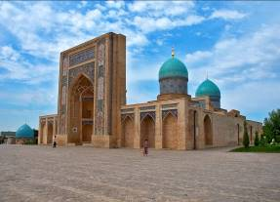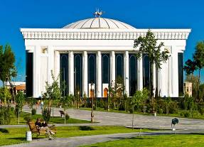

**Day 2, Fri: Khiva B/L/D**

Today you will have a wonderful sightseeing tour in the oldest city of Uzbekistan. It will be inside of Ichan-Qala,the inner city in Khiva rounded with strong walls. Centuries old sound buildings, palaces, mosques, Madrasahs, Mausoleums, Minarets, Caravan-Sarais and Bathhouses transformed Ichan-Qala into unique city-monument. Ichan-Qala consists of over 400 traditional dwelling houses and about 60 architectural monuments. In 1969 Ichan-Qala was designated a historical and architectural conservation area. The most remarkable sites in it are the Kunya-Ark fortress dating back to 17th century, found by Muhammad Arang Khan, Kalta Minor minaret and Tash Khouvli palace, an incredible sample of Khorezm architectural mastership of 1830s. Night is in a hotel.

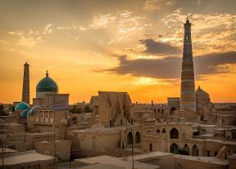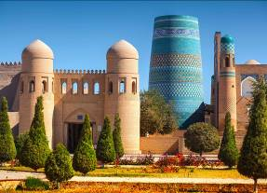

**Day 3, Sat: Khiva – Bukhara (440 km, 7 hours) B/L/D**

Early in the morning we will have transfer to a fascinating city of Bukhara. With its more than 140 architectural monuments Bukhara is a "town museum" dating back to the Middle Ages. The city consists of narrow streets, green parks and gardens, historical and architectural monuments belong to different epochs, but locate very close to each other. The road from Khiva to Bukhara goes through famous Kizilkum desert. On the way we will enjoy the view to Amu Darya river, the deepest river in Central Asia, formed by the confluence of the Panj and Vakhsh in Tajikistan) and flowing into Aral See. Upon arrival in Bukhara, you will have free time. Night is in a hotel.

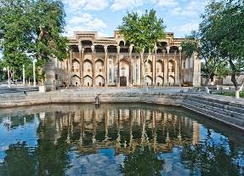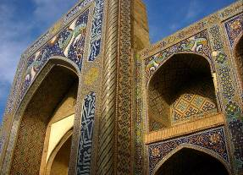

**Day 4, Sun: Bukhara B/L/D**

Today you will have a full day of sightseeing tour in the fascinating city of Bukhara. At first you will visit the most ancient citadel in Bukhara dating back to the 4th century named Citadel Ark which served as a palace for several dynasties of Bukhara Empire. Then you will see Samanids mausoleum, a real masterpiece of architecture of 9th -10th century. Then the tour continues to Chashma Ayub, meaning Job's well and Bolo-Hauz mosque, known also as the mosque of forty columns built in honor of Bukhara governor Abu-Fayud Khan. Then you have a chance to walk along the shopping domes and visit one of the most famous madrasahs of Bukhara called Nodir Divan Begi which is also a part of Lyabi House Ensemble, famous central sightseeing of Bukhara. The tour will end with visitingPoi Kalon complex, the unique sample of architectural art of Bukhara. It consists of three structures built in the 12th - 16th centuries: Kalon minaret, Kalon mosque and Mir Arab Madrasah. Dinner will be at national restaurant, following by dancing show program. Overnight.

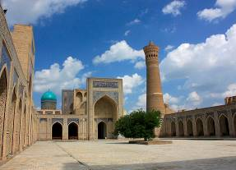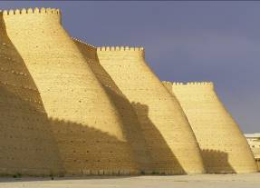

**Day 5, Mon: Bukhara – Gijduvan – Samarkand B/L/D**

After breakfast, we will start our way to Samarkandmics school has its deep roots. The skills have been passed from father to son from generation to generation. Today Gizhduvan is home for the sixth generation of potters from Narzullayevs family which glorified Gijduvan school ceramics all over the world. Gijduvan School of ceramics is distinguished by a geometric pattern. Green and blue colors prevail in decoration of products. On the way visitmemorial complex of Al Bukhary. Al Bukhary was an Islamic scholar, who authored the hadith collection known as Sahih al-Bukhari, regarded by Sunni Muslims as one of the most authentic Hadith collections. Afterwards we continue driving to Samarkand. Dinner and overnight.

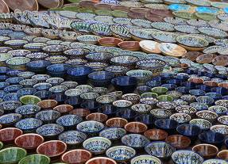

**Day 6, Tue: Samarkand B/L/D**

Samarkand is situated in the valley of the river Zerafshan. It is the second largest city of Uzbekistan and is of the same age as the city of Babylon or Rome. Today you will visit its most outstanding sights such as Registan square, Shakhi-Zindeh, Mausoleum Guri Emir and Bibi Khanum Mosque.Registan Square, acomplex of three fascinating Madrasahs dating back to 15-17th centuries, is the main highlight of Samarkand that no person can stop admiring its beauty and majesty. Architectural complex of Shakhi-Zindehrepresents a big collection of mausoleums dating back to 11th-15 centuries being a part of a UNESCO World Heritage Site. Bibi Khanum Mosque was built in honor of favorite Tamerlane’s wife, after his successful campaign in India. Afternoon drive to Tashkent. Dinner is at national restaurant with dancing show program. Overnight is at the hotel.

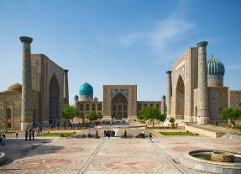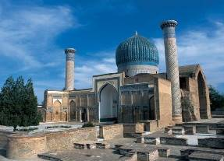

**Day 7, Wed: Samarkand – Tashkent (350 km, 4.5 hrs drive) B/L/D**

Today you will continue exploring Samarkand city. You will visit Ulughbek observatory, built in 15th century by Ulughbek, one of the most famous Samarkand rulers and scientists. Working in observatory, Ulughbek created in 1437 the “Zidji Guragoni” catalog, which had information about 1018 celestial bodies. Unfortunately, he was killed by order of his own son. After it you can walk along the Local Broadway surrounded by souvenir shops, teahouses, sweets and workshops. Then you can visit National bazaar Siab, oriental bazaar, where it is easy to find Uzbek traditional handmade products and local sweets. Also you will see carpet factory, a unique handmade carpet factory where over 400 women sew carpets without using traditional techniques. Afternoon transfer to Tashkent (350 km, 4.5 hrs drive or alternative is by train). Night is in a hotel.

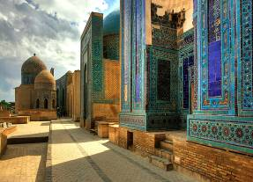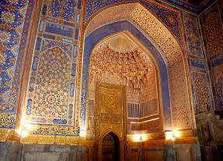

**Day 8, Thu: Tashkent – Chimgan Mountains – Tashkent – Flight home B/L**

In the morning you will transfer to Chimgan Mountains. Upon arrival you will have a chair lift to reach the top to see Beldersay peak 30 min one-way. Here you will have some free time for walking around, enjoying the nature. On the way back you will stop over at Charvak lakeside beach for free time and own water activities (as per season). Charvak is an artificial lake, a popular resort in Tashkent region and thousands of holiday makers from all over Uzbekistan and neighboring countries visit the reservoir. In the end of the day is return to Tashkent. Last minute shopping in Tashkent Malls. 18:00 transfer to airport, flight home is at 21:25.

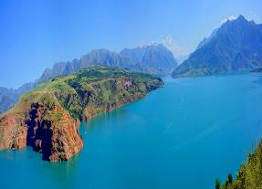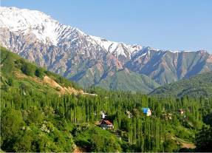

**Travel Map:**

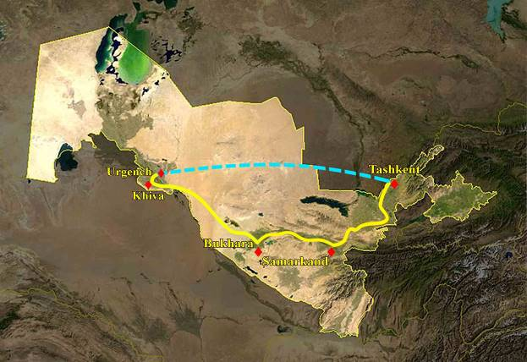

**Type of transport:**

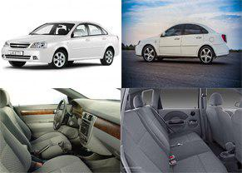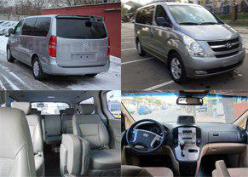

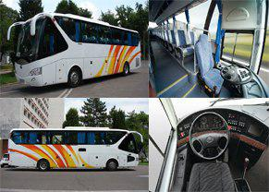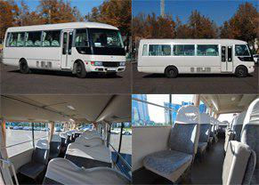

**Pricing**

|  |  |  |
| --- | --- | --- |
| Persons | Price per person in USD | |
| Option A | Option B |
| 2 | 910 | 1025 |
| 4 | 820 | 935 |
| 6 | 730 | 845 |
| 8 | 675 | 775 |
| 10 | 650 | 765 |
| 10+1 Foc | 640 | 765 |
| 15+1 Foc | 605 | 715 |
| 20+1 Foc | 565 | 670 |
| 25+1 Foc | 535 | 645 |
| 30+1 Foc | 520 | 625 |
| 35+1 Foc | 505 | 610 |
| 40+1 Foc | 500 | 600 |
| Single Supplement | 90 | 250 |
| Bullet Train  Samarkand-Tashkent | 20 – economy  40 – business | |

|  |  |  |  |
| --- | --- | --- | --- |
| Cities | Nights | Option A | Option B |
| Tashkent | Two | Samir 3* | Ramada 4* |
| Khiva | One | Old Khiva 3* | Bek Khiva 4* |
| Bukhara | Two | Old City 3* | Omar Khaym 4* |
| Samarkand | Two | Ideal 3* | Diyora 4* |

**Price includes:**

* Accommodation at mentioned hotels on double share basis
* Transportation per program in comfortable a/c transport with professional drivers
  + 2 pax – Sedan (Lacetti Chevrolet)
  + 4-8 pax – Minivan (Grand Starex, Istana)
  + 10-14 pax – Midibus (Mitsubishi Rosa, Sprinter)
  + 15 and more pax – Big Bus (Yutong, Higer)
* Breakfasts at the hotels
* All lunches and dinners per program
* Daily two bottles of 0.5l water per person
* All master classes and show programs per program (groups of 15 pax and more)
* Escort English speaking guide for entire tour (Bahasa speaking is as per request)
* Entrance fees to mentioned sights per program (excluding photo and video charges at sights)

**Price does not include:**

* Visa consular fees and processing expenses
* Photo and video charges at sights
* International air tickets to / out of Tashkent
* Domestic flight: Tashkent – Urgench
* Bullet train tickets
* Travel Insurance
* Extras, not indicated in inclusions

**PS:**

* Pricing valid for contracted partners only for mentioned dates
* If mentioned hotels are overbooked or not available, we will give appropriate alternative.
* If there is no free seats in bullet train, we will replace by normal train.

**Payment:**

* Tour payment should be made not less than 40 days prior to tourist group arrival to our bank account as per sent invoice.
* The rooming list should be finalized 30 days before arrival.

**Cancellation fees:**

* No charges up to 45 calendar days up to tour starting date
* 50% of full package price up to 14 calendar days up to tour starting date
* 100% of full package price – 7 or less working days up to tour starting date or no show.